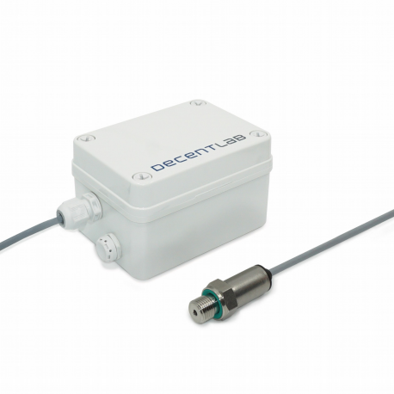
DL-PR21 DATASHEET
PRESSURE / LIQUID LEVEL AND TEMPERATURE SENSOR WITH PIPE THREAD FOR LORAWAN ®
FEATURES
LoRaWAN®-enabled piezoresistive pressure sensor / depth gauge.
Range: -1 ... 10 bar (up to 100 m depth); resolution: 0.000336 bar (3.36 mm).
Cable length: 2 m.
Industry standard pipe connection G 1/4” (NPT 1/4” available on request).
Compatible with LoRaWAN® networks of any provider.
Place and measure: no setup required.
Configurable via command line interface and downlink command interface.
Unattended real-time monitoring for several years without replacing batteries.
Robust polycarbonate enclosure: weatherproof, impact-, UV-resistant (IP67).
Standard alkaline (C-type) batteries.
CE compliant, Radio Equipment Directive (RED) 2014/53/EU.
APPLICATIONS
Outdoor remote monitoring.
Level / depth monitoring in tanks for liquids. Pressure monitoring in pipelines and tanks. District heating monitoring, leakage detection.
Water distribution network: monitor pressure, control pumps.
Relative pressure measurement.
DL-PR21 Datasheet 2
DESCRIPTION
The device DL-PR21 enables remote monitoring of pressure in pipelines or tanks. It measures the pressure at the G 1/4” pipe connection relative to the pressure at the cable entry. When the sensor head is mounted at the bottom of a water tank, the relative pressure indicates the depth of the sensor head (fill level). In water, the relative pressure of 1 bar equals to a depth of approximately 10 m.
The device also records the temperature of the sensor head. The temperature reading is used for temperature compensation.
Sensor data are transmitted in real-time using LoRaWAN® radio technology. LoRaWAN® enables encrypted radio transmissions over long distances while consuming very little power. The user can obtain sensor data through Decentlab’s data storage and visualization system, or through the user's own infrastructure. Visit www.decentlab.com for more information about Decentlab's data cloud service.
DEVICE VARIANTS
Name Range Application
DL-PR21-001 -1 ... 10 bar Pressure monitoring in tanks, pipelines other ranges: contact us
DL-PR21 Datasheet 3
DEVICE SPECIFICATIONS
DEVICE LOGGING FUNCTION
Sampling interval 10 min (configurable through the user interfaces) Data upload interval 10 min (configurable through the user interfaces)
Reported sensor data (average of samples)
Pressure
Temperature Battery voltage
SD-card logging Optional
PRESSURE SENSOR
Operating principle Piezoresistive pressure measurement Measurement range -1.0 ... 10.0 bar
Resolution 0.000336 bar / 3.36 mm (= full scale / 32768) Linearity / precision max. ±0.15 % of full scale
Total error band
(max. deviation within 0 … 50 ºC) TEMPERATURE SENSOR
max. ±0.7 % of full scale
Resolution 0.003125 ºC
Accuracy ±2 ºC (typical)
RADIO / WIRELESS
Wireless technology LoRaWAN®
Wireless security AES-128 data encryption
LoRaWAN® device type Class A end-device
Supported LoRaWAN® features OTAA, ABP, ADR, adaptive channel setup
Wireless range > 10 km (line of sight¹), approx. 2 km (suburban) RF transmit power 14 dBm (25 mW)
Effective radiated power 11.9 dBm maximum²
Receiver sensitivity -146 dBm ³
Frequency bands 868 MHz (EU version), 915 MHz (US, AS, AU versions)⁴
Antenna Integrated omnidirectional antenna featuring a near-perfect radiation pattern²
1 Decentlab reports successful transmissions over 56 km distance and more
2 See Appendix A: Antenna performance
3 Specified by radio chip vendor
4 Contact us for region specific options
DL-PR21 Datasheet 4
POWER SUPPLY
Internal battery type 2 × alkaline C batteries (LR14)
Power consumption (average) ≤ 0.4 mW (10 min interval)
Battery lifetime estimation⁵ 9.5 years (10 min interval, SF7)
4.8 years (10 min interval, SF12)
14.0 years (60 min interval, SF7)
11.0 years (60 min interval, SF12)
OPERATING CONDITIONS
Temperature -20 ... 50 °C
Humidity 0 ... 100 % RH
MECHANICAL SPECIFICATIONS
Dimensions 135 × 81 × 70 mm (not including sensor / cable) Weight 510 g including batteries and sensor (380 g without batteries) Enclosure Polycarbonate; weatherproof, impact-, UV-resistant (IP66/IP67). Pressure equalizer plug with PTFE membrane (IP68).
Cable length 2 m (custom cable lengths: contact us)
Sensor head Length: 56 mm, diameter: 21 mm
5 Including alkaline battery self-discharge of 3.6 % per year (conservative estimation); battery capacity: 20000 mWh. DL-PR21 Datasheet 5
OPERATING INSTRUCTIONS
The product usually requires no user interaction. If you open the enclosure, e.g. in order to replace the batteries, unscrew the four plastic screws and carefully open the lid.
CAUTION: Make sure the sensor unit does not drop out of the enclosure while opening! Do not touch the electronic components and sensors!
NOTE: When closing the lid, make sure the lid is fitted the right way, so that the enclosure is properly sealed: A little nose in the enclosure fits a notch in the lid and vice versa.
REPLACING BATTERIES
Insert 2 high-quality alkaline C batteries (LR14) into the battery holder on the back side of the sensor unit. The device operates until the battery voltage drops to 2.0 V. Always replace both battery cells with two identical fresh batteries.
USER BUTTON AND LEDS
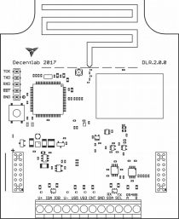
User
button
LEDs
Illustration 1: Sensor unit showing the user button and LEDs. The battery
holder is on the back side of the sensor unit.
DL-PR21 Datasheet 6
OPERATING MODES
The device has four operating modes:
• Reset: System (re-)start; both LEDs fade in and out.
• Active mode (ON): Periodic measurements and data transmissions; green LED flashes for each measurement.
• Sleep mode (OFF): No measurements and data transmissions (power save mode, for shelf storage). LEDs are off.
• Test mode: Measurements and data transmissions at fastest possible rates; blue LED is on. NOTE: Use only momentarily, e.g. for testing the sensor or the wireless connection. The device will switch automatically to active mode after 20 minutes.
SWITCHING BETWEEN OPERATING MODES
The user button allows to switch between the operating modes as shown in Illustration 2 and Illustration 3. To perform a device reset, switch to sleep mode first (if necessary) by pushing and holding the button for 3 seconds until the LEDs flash three times; wait 3 seconds; then push and hold the button for 3 seconds until the LEDs fade in and out. To switch between active and test mode, push the button for 1 second (blue LED on / off). If the blue LED is off, the device is in active or sleep mode. If the blue LED is on, the device is in test mode.
HINT: To check whether the device is active or in sleep mode (on or off), push the button twice; if the blue LED goes on and off, the device is in active mode; otherwise, the device is in sleep mode.
Green LED flashes when measuring
Active
Press and hold button (3 sec)
LEDs flash 3 times
Sleep
Press and hold button (3 sec)
LEDs fade in and out
Reset
Illustration 2: Switching between active and sleep mode (switch off / on, reset).
Green LED
flashes when
_{measuring} Blue LED on
Press button
(1 sec)
Active Test
Press button (1 sec)
Illustration 3: Switching between active and test mode.
DL-PR21 Datasheet 7
MEASUREMENT CYCLE (ACTIVE MODE)
During the active mode, the device periodically reads the sensors with sampling period T_{S} = 10 minutes (default, configurable). When the send period T_{TX} = n · T_{S} (default: n = 1, configurable) has expired, the device computes the average of the collected sensor values (at most 20 values). After a random delay of 0 … 8 seconds, the device transmits the aggregated sensor data. If the device has not yet joined the LoRaWAN® network, it will try to join until it succeeds (maximum 3 attempts per sampling period). Afterwards, it will transmit the data (TX data). Following the data transmission, two receive slots are opened (RX1 and RX2). During these time slots, the device is ready to receive data from the network (downlink messages) as defined in the LoRaWAN® specification.
As shown in the diagrams, the device is idle most of the time. During the idle time, the current consumption is extremely low.
Idle Idle
Read sensors
_{TX data RX1 RX2} Delay 0...8 s
Illustration 4: Device activity during the active mode.
Sampling period TS
Send period TTX = n · TS
Illustration 5: Sampling period vs. send period. Default: T_{S} = 10 min, T_{TX} = 1 · 10 min = 10 min.
LED SIGNALING (ACTIVE MODE)
• Read sensors: green LED flashes once.
• Data sent successfully: green LED flashes 2 times.
• Data could not be sent: green LED flashes 4 times.
DL-PR21 Datasheet 8
DEVICE CONFIGURATION
The user can configure a rich set of device parameters, such as sampling interval, LoRaWAN® data rate, ADR settings and many more. If desired, the parameter settings can be stored permanently in the internal non-volatile memory. The user can configure the device via two interfaces:
• Command line interface: via a serial cable (UART – USB) connected to a computer. • Downlink command interface: over the air using LoRaWAN® downlink messages.
For a full description of the command line interface and the downlink command interface, please find the specific documents on www.decentlab.com/support.
DL-PR21 Datasheet 9
MOUNTING INSTRUCTIONS
Prefer a mounting location which is protected against rain and direct sun radiation.
For best radio performance, install the device upright with the cable towards ground; ideally, in such a way that the device lid faces roughly in the direction of the next gateway. Also, the higher above ground, the better. Avoid metallic objects close to the device.
The housing includes 4 threaded bushes (M4) in a 90 × 60 mm rectangle (see Illustration 6). This enables easy installation using standard M4 bolts.
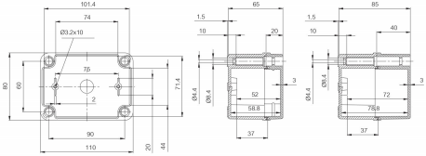Illustration 6: Housing dimensions (in mm). Note: Drawing not including cable gland and sensor.
DL-PR21 Datasheet 10
ORDERING INFORMATION
REFERENCE VERSION REGION (LORAWAN ®) DL-PR21-001-EU868 001 Europe
DL-PR21-001-US915 001 North America DL-PR21-001-AS923 001 Asia
DL-PR21-001-AU915 001 Australia, South America Other options: contact us
DL-PR21 Datasheet 11
SENSOR DATA MESSAGE FORMAT
Message:
Header | Sensor 0 data (optional) | Sensor 1 data (opt.) | ... | Sensor 15 data (opt.)

• Message length is variable, depending on which sensor data are included. Minimum length is 5 bytes (header only). Maximum length is 5 bytes + all sensor data (see below).
• Integers are big endian: MSB first byte, LSB last byte.
Header:
Version | Device ID | Flags

• Version: 1 byte; version = 2 for current protocol version.
• Device ID: 2 bytes; 0...65535.
• Flags: 16 bits: flag 15 | flag 14 | … | flag 0 (LSB).
• The flags indicate, if data of the respective sensors are included in the message or not: Flag n == 1: sensor n data included; flag n == 0: not included.
DECODER SOFTWARE
For message decoder software, please go to https://www.decentlab.com/support, where you find code examples in JavaScript and other programming languages.
DETAILS
FIELD PARAMETER NAME TYPE CONVERSION UNIT Header Version uint8
Header Device ID uint16
Header Flags uint16
Sensor 0 Pressure uint16 (x − 16384) / 32768 ∙ (P_{max} − P_{min}) + P_{min} bar Sensor 0 Temperature uint16 (x − 384) / 64000 ∙ 200 − 50 °C Sensor 1 Battery voltage uint16 x / 1000 V
Note: The values of P_{min} and P_{max} are indicated on the pressure sensor (e.g. -1 … 10 bar: P_{min} = -1.0 bar, P_{max} = 10.0 bar).
DL-PR21 Datasheet 12
EXAMPLE 1 (ALL SENSOR DATA INCLUDED)
Message (hex):
02016700034e8060170c7f
02 Version = 2
0167 Device ID = 359
0003 Flags = 0b0000000000000011
4e80 Pressure = 0.2461 bar
6017 Temperature = 25.67 deg 0c7f Battery voltage = 3.199 V
EXAMPLE 2 (ONLY BATTERY VOLTAGE)
Message (hex):
02016700020c7f
02 Version = 2
0167 Device ID = 359
0002 Flags = 0b0000000000000010
---- Pressure = ---- bar
---- Temperature = ---- deg 0c7f Battery voltage = 3.199 V
DL-PR21 Datasheet 13
DECLARATION OF CONFORMITY
We,
Decentlab GmbH
Überlandstrasse 129
8600 Dübendorf
Switzerland
declare under our own responsibility that the product
Reference Name
DL-PR21-xxx-EU868 Pressure / Liquid Level and Temperature Sensor with Pipe Thread for LoRaWAN®
to which this declaration refers conforms with the relevant standards or other standards documents • EN 300 220-1 V3.1.1: 2017-02
• EN 300 220-2 V3.1.1: 2017-02
• EN 301 489-1 V2.2.0: 2017-03
• EN 301 489-3 V2.1.1: 2017-03
According to
• Radio Equipment Directive (RED) 2014/53/EU
• Electromagnetic Compatibility (EMC) Directive 2014/30/EU
Dübendorf, 12. September 2018
Reinhard Bischoff, Managing Director
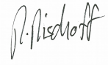
DL-PR21 Datasheet 14
APPENDIX A: ANTENNA PERFORMANCE 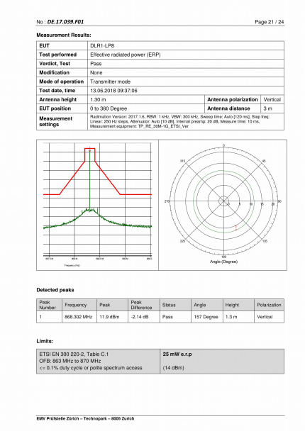DL-PR21 Datasheet 15
DISCLAIMER
Specifications and information in this document are subject to change without notice.
Decentlab products are not warranted or authorized for use as critical components in medical, life saving, or life-sustaining applications, or other applications where a failure would reasonably be expected to cause severe personal injury or death.
CONTACT INFORMATION
www.decentlab.com/contact
mail @decentlab.com
+41 44 809 35 90
Decentlab GmbH
Überlandstrasse 129
8600 Dübendorf
Switzerland
DL-PR21 Datasheet 16

